# Introduction

Missing foods can be reported in Intake24 by study participants when they search for a particular food and are unable to find it in the food list. If they click on ‘I can’t find my food’ and then ‘Report a missing food’, they are asked to provide further details about this item (see Figure 1). The answers provided will appear in your data extract columns as shown in Table 1.

This document contains guidance on how to 1. Find, 2. Resolve and 3. Assign missing foods in your Intake24 dietary dataset. The process should ideally take place once a participant has completed all their expected recalls. This is because the information a participant provides in subsequent or previous recalls may help inform coding decisions for their reported missing foods.

Figure 1. Screenshots from the Missing Foods form in Intake24 which participants use to enter further details about the item they could not find. If a barcode is provided, online tools are available to link the barcode to a food/drink product. Please note that some schemes do not have barcode enabled, in which case participants will not be able to use this feature.

If ‘no’

If ‘yes’

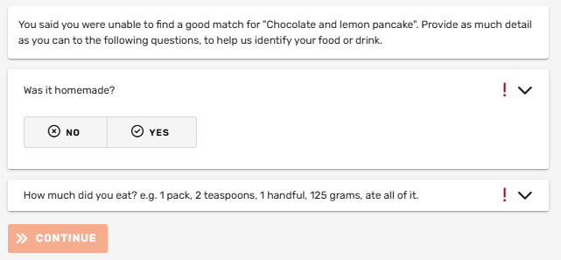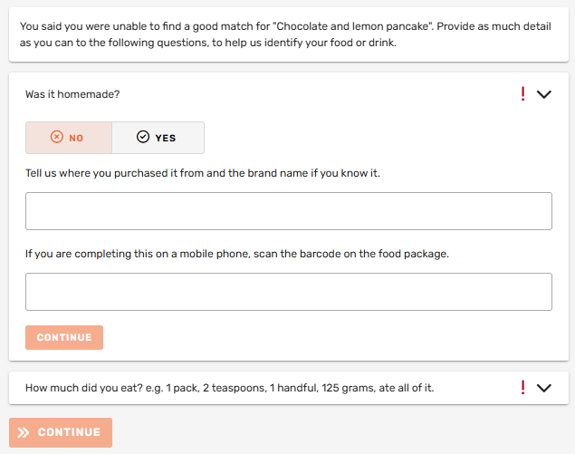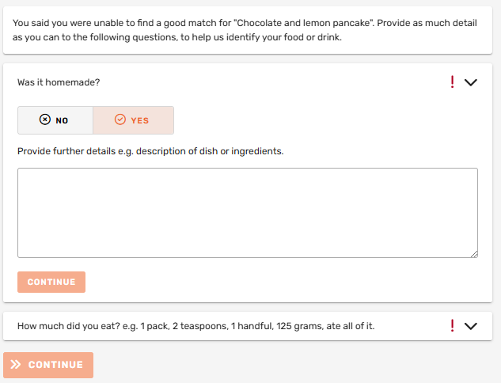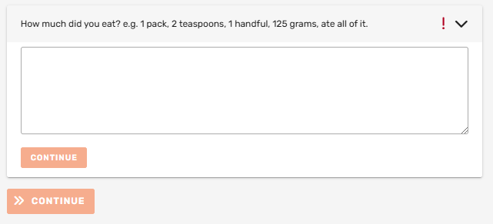

Table 1. How to find missing foods details provided in Data Extract based on questions on Missing Foods form

|  |  |
| --- | --- |
| **Question on Missing Foods form** | **Column name in Data Extract** |
| Original search term | Missing name |
| Provide further details e.g. description of dish or ingredients (If ‘yes’ to homemade question) | Missing description |
| Tell us where you purchased it from and the brand name if you know it. (If ‘no’ to homemade question) | Missing brand |
| If you are completing this on a mobile phone, scan the barcode on the food package. (If ‘no’ to homemade question) | Missing barcode |
| How much did you eat? e.g. 1 pack, 2 teaspoons, 1 handful, 125 grams, ate all of it. | Missing portion size |

Since the missing foods reported are not linked to a food and portion size by the participant, there is no nutritional and portion information attached to them in the dataset, instead showing as blanks for these variables.

# FIND: Locating missing foods in the dataset

Download a data export from Intake24 and filter to the rows that have entries in column AY (Missing food ID). When processing the data and reviewing missing foods, you might want to consider adding an extra column for comments and notes, if there is anything you need to discuss with your team.

Check the missing foods for common entries and where necessary, check Intake24 to try to recreate the participants search for their missing food using the search term to investigate why this item was not found. If a food is regularly appearing as a missing food in your data and being reported by multiple participants, you may wish to consider amending your fieldwork instructions accordingly.

For missing foods that appear multiple times, you can contact us ([support@intake24.org](mailto:support@intake24.org)). It may be possible to add additional foods to the tool subject to overall fit within the Intake24 food database.

# RESOLVE: Deciding on a food code and portion size

## Deciding the food code

Use the [McCance and Widdowson’s composition of foods integrated dataset](https://www.gov.uk/government/publications/composition-of-foods-integrated-dataset-cofid) an [archived version of the Nutrient Databank](https://beta.ukdataservice.ac.uk/datacatalogue/doi/?id=8956#!), or other relevant food composition dataset, to find an appropriate match for your missing foods.

Use all the available information provided by the participant in the Intake24 data extract and particularly the missing food columns (see Table 1) to help decide the best match.

Check the rest of the recall and other recalls completed by the same participant, where possible, to see if they have eaten the same or similar foods elsewhere. This is particularly useful when limited missing food information is recorded by the individual.

Use consumption data across all your data to inform decisions when detail provided by the participant is lacking. E.g. ‘cereal’ may have been reported missing but no further details are given and the participant has not consumed this again. You may wish to consider referring to the consumption data across the study to determine the most popular cereal consumed so far and assign this to the missing food reported.

Choose the best basic match if there is no clear match and try to think like the participant would. Table 2 shows some examples of how foods can be matched.

Table 2. Examples of missing food search terms and foods they can be matched to

|  |  |
| --- | --- |
| **Missing food search term** | **Matching foods** |
| Beetroot soup | Carrot soup |
| Beans with chicken and salad | Chicken salad |
| Freeze dried strawberries | Dried strawberries |
| Homemade salmon curry | Fish curry |
| Belvoir Ginger cordial | Elderflower cordial |

Discuss with others in your team to help come to a decision if needed.

Enter the decided food code, taken from your chosen food composition database, in the Nutrient table code column of your data extract.

A copy of the Intake24 food list, along with the food composition codes can be made available; please get in touch if needed.

## Deciding the portion size

Use the information from the missing food section in the participants recall to decide a suitable portion size. If the participant hasn’t provided sufficient portion size information you could consider the following:

* + If the participant has reported a comparable food or drink item in the rest of their recall or in another of their recalls, you could decide the portion size based on this e.g. reported cornflakes as missing but in a different recall, they entered Special K with portion details.
  + If brand or supermarket information has been reported for the missing food, it may be possible to find the weight by searching online or identifying a similar product with a weight.
  + Use portion data from the rest of the dataset to help determine a suitable portion size to assign, according to the food reported as missing. E.g. if none of the above solutions work and you aren’t sure of a portion size to assign to a bowl of cornflakes, work out the average portion size reported for other flake cereals across your whole dataset (note that if you are looking for a portion for an adult, you may need to exclude children when working out the average).
  + You can use our [demo survey](https://app.intake24.org/demo) to look up portion weights e.g. using the middle As Served image for default average portions

Other sources that can provide standard portion sizes include:

* Food Standards Agency Food Portion Sizes (TSO; 3rd Edition)
* <https://www.bda.uk.com/resource/food-facts-portion-sizes.html>

Enter the decided portion size value in grams in the Portion size (g/ml) column of your data extract.

## Dealing with multiple foods e.g. recipes/mixed dishes

If a participant has provided a recipe in the missing foods description form, it is advisable to assign it to a single code from your chosen food composition source that best matches what they have eaten, rather than attempting to add multiple ingredients. One individual food item is unlikely to significantly impact your data and it is easier from a data management perspective to not have to create multiple lines of intake for one dish. However, if it is necessary to assign multiple food codes, you will have to determine a way to link these as a recipe/mixed dish within your data.

If multiple foods have been entered on one line but these do not make up a recipe (e.g. ‘sandwich, crisps, apple’), these should be dealt with on a case-by-case basis. You can either try to find a single food to represent them, assign multiple food codes, or just assign codes for the most important items, depending on your study aims.

## Duplicates

In some cases, a participant may report a food as missing, but you may then see the same food coded in the same eating occasion. This is probably because they ended up finding what they were looking for. If you are certain that the missing food is a duplicate, this entry can be marked as to ignore.

# ASSIGN: Entering the food code and portion size

You can use the VLOOKUP formula in Excel to insert the nutrient values from the food composition database into your data extract, using the Nutrient table code you entered and taking into account the portion size assigned.

Alternatively, you can use your statistical software of choice to assign the values, or any method recommended by your Data Manager.